Lab 7: Fuzz Testing
ATM Withdrawal (L6_L7_18_atm_withdrawal)
Name: Shreesh Athreya
SRN: PES1UG24CS441
Class: 5H
Repository: https://github.com/cswizard7/L6_L7_18_atm_withdrawal

Step 1: Installing dependencies
Commands: python -m pip install hypothesis and python -m pip install pytest
Installed Hypothesis 6.170.15 and pytest 9.2.0 on Python 3.13.1 (Windows 11).

Step 2: Running the buggy application
Command: python atm_withdrawal.py
Entering the non-numeric amount "abc" crashes notes_needed with an unhandled ValueError, because the input is passed straight to int() without validation.
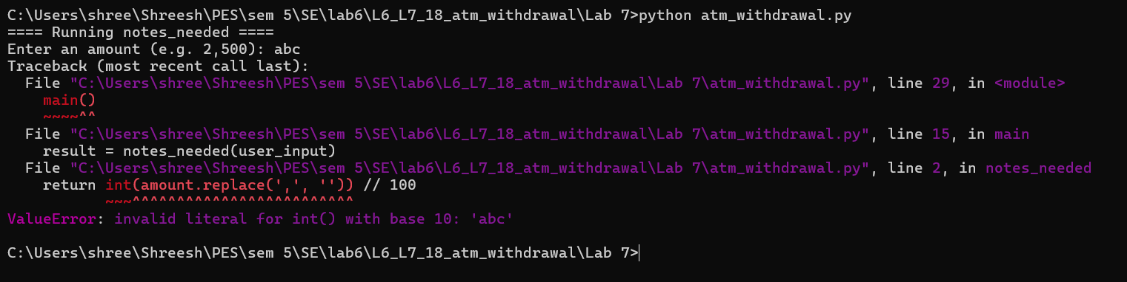
Figure 1: Buggy application crashing on invalid input

Step 3: Hypothesis fuzz tests
test_atm_withdrawal.py contains six Hypothesis tests covering all three functions:
- No-crash tests: each function is fuzzed with random Unicode text and None (st.text() | st.none()); any exception counts as a failure.
- Input-validation tests: generated integers, digit groups and CSV lists check that invalid amounts and card numbers are rejected and valid ones give the correct result.

Step 4: Fuzz tests on the buggy application
Command: python -m pytest test_atm_withdrawal.py
All 6 tests fail. Hypothesis found 2 distinct failures in several of the tests and shrank each one to a minimal failing input, such as amounts=[0].
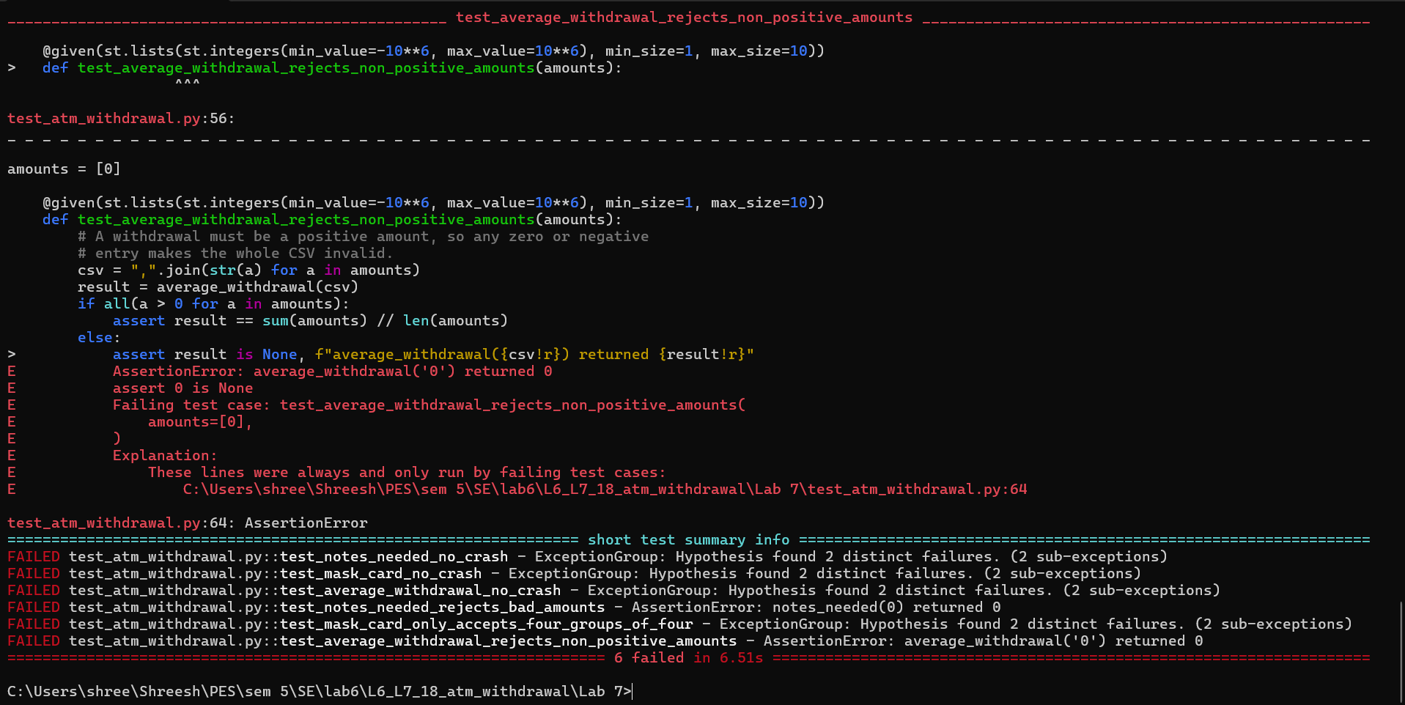
Figure 2: All six fuzz tests failing on the buggy code

Bugs found and fixes applied
Function | Bug found by fuzzing | Fix
notes_needed | Crashed on None and non-numeric text (AttributeError / ValueError); returned a note count for 0, negative amounts and amounts not a multiple of 100. | Checks the input is a string of ASCII digits, rejects zero and non-multiples of 100, returns None for invalid input.
mask_card | Crashed on None and on fewer than 4 groups (IndexError); accepted any text with 4+ groups, e.g. '1 2 3 4'. | Accepts only exactly 4 groups of 4 ASCII digits; returns None otherwise.
average_withdrawal | Crashed on None, empty string, empty entries like '1,,3' and non-numeric text; averaged zero and negative withdrawals. | Validates every entry as a positive whole number; returns None if any entry is invalid.

Step 5: Running the fixed application
Command: python atm_withdrawal.py (run twice)
First run with invalid input: each function now prints a clear "Invalid …" message instead of crashing. Second run with valid input: the results are unchanged.
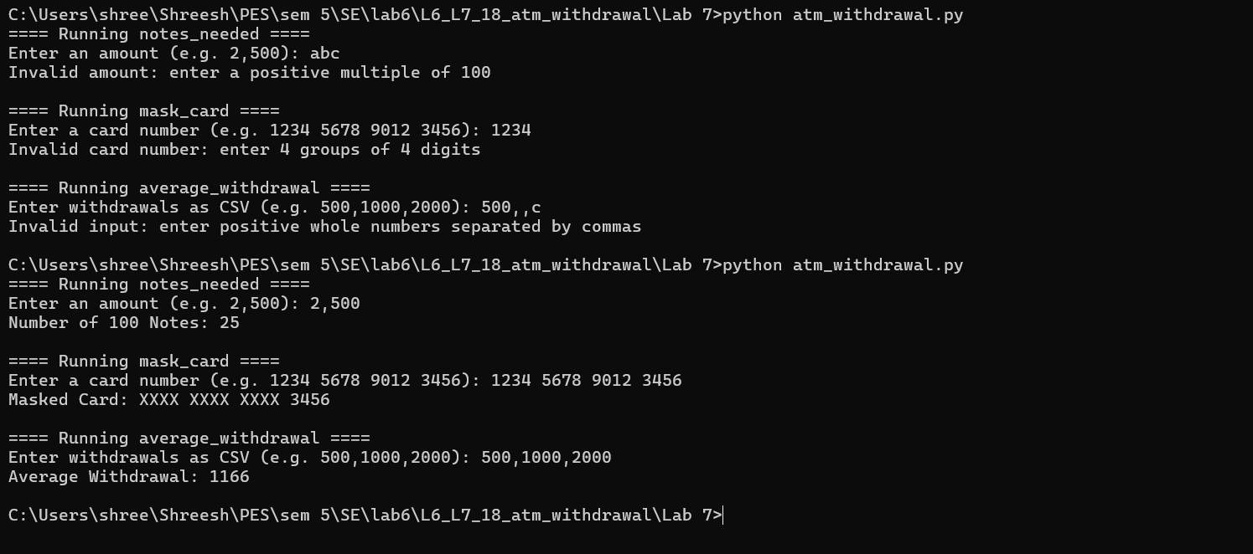
Figure 3: Fixed application handling invalid and valid input

Step 6: Fuzz tests on the fixed application
Command: python -m pytest test_atm_withdrawal.py
All 6 fuzz tests pass against the fixed code.
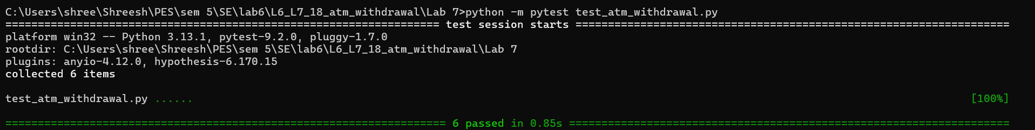
Figure 4: All six fuzz tests passing on the fixed code

